·         *Article rank*

·         *28 May 2020*

·         *The Washington Post*

·         *BY MICHAEL BIRNBAUM AND LOVEDAY MORRIS* [*loveday.morris@washpost.com*](mailto:loveday.morris@washpost.com)[*michael.birnbaum@washpost.com*](mailto:michael.birnbaum@washpost.com) *Morris reported from Berlin. Quentin Ariès in Brussels, Chico Harlan in Rome and Luisa Beck in Berlin contributed to this report.*

# E.U.’S $825 billion rescue plan could be transformative

## Proposal grants powers to Brussels usually held by federal states

BRUSSELS — European Union leaders on Wednesday proposed an $825 billion coronavirus rescue plan that would give Brussels major new tax and spending powers of the sort held by a federal state.

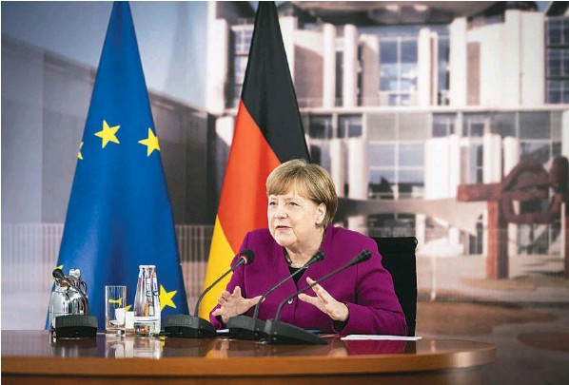SANDRA STEINS/BUNDESREGIERUNG/AGENCE FRANCE-PRESSE/GETTY IMAGES**German Chancellor Angela Merkel has dramatically shifted her stance and is encouraging the E.U. to abandon old constraints, borrow money in vast quantities and channel the cash to the needy nations.**

Proponents are calling it Europe’s “Hamiltonian moment,” after the 1790 agreement, engineered by Treasury Secretary Alexander Hamilton, that transformed the United States from a loose confederation of former colonies into a true federation with a central government.

If approved, the E.U. plan could bind the bloc together at a moment when it seemed at risk of spinning apart under the pressure of the novel coronavirus pandemic. If the plan fails — either to win support or to deliver benefits — euroskeptic politicians could be emboldened, both in rich nations such as Germany and struggling ones such as Italy.

The E.U. plan would allow the bloc to raise money centrally and then redistribute it — something it has never done before. Brussels would offer $550 billion in the form of grants to member countries hit hardest by the economic fallout from the virus. The remainder of the aid would be in the form of loans with strings attached, which more closely mirrors measures of the past.

“We either all go it alone,” said European Commission President Ursula von der Leyen, announcing the plans in the sparsely populated hall of the European Parliament, “or we walk that road together, we take that leap forward, we pave a strong path for our people and for the next generation.”

In an effort to calm fears from countries skeptical of tighter integration, she emphasized that this would be a one-time crisis measure.

The proposal came after a change of heart in Germany, Europe’s most powerful economy. Chancellor Angela Merkel has always fiercely guarded her country’s bank accounts from the E.U.’S weaker members. Now, she has dramatically shifted her stance and is encouraging the E.U. to abandon old constraints, borrow money in vast quantities and channel the cash toward the needy nations.

Merkel’s ability to deliver will frame her legacy. She has vowed to step down by the end of her term next year.

“It was a question of the survival of the European Union,” said Wolfgang Ischinger, a former German ambassador to the United States who is now the head of the Munich Security Conference and has close ties to German policymakers.

“This is not simply a gift which we give away because we like our neighbors so much,” Ischinger said. “It’s about assuring the survival of the European project to which Germany has now been attached to for the last 70 years. Our political future. And we’re not going to let that fall apart.”

The 27 E.U. countries sometimes seem to have 27 different ideas about how to work together, and any economic rescue package will still need unanimous sign-off. Already, Austria, Denmark, the Netherlands and Sweden have signaled their strong preference that help be confined to loans with strings attached, although they have also indicated a willingness to negotiate.

Tensions have been building since the opening weeks of the European outbreak, when Italy and then Spain faced mounting death tolls and the E.U. didn’t come to their aid. Germany and France both briefly banned exporting medical equipment such as N95 masks, infuriating Rome, which felt it had been abandoned. China rushed over masks and medical advisers, in a major public relations win for Beijing.

Then, at the end of March, as Prime Minister Giuseppe Conte pleaded with E.U. countries to help Italy fight its growing economic challenges, he was spurned by richer neighbors to the north. One official, Dutch Finance Minister Wopke Hoekstra, said the E.U. should investigate why some countries couldn’t manage the economic turmoil of the pandemic on their own.

European policymakers and analysts began to warn about lasting damage to the union.

“We are talking about a crisis that has completely undermined the single market. It has undermined democracy in at least one state. And it has reawakened the lack-of-solidarity debate, coming on the heels of the euro zone crisis and the migration crisis,” said Nathalie Tocci, the head of the Italian Institute of International Affairs, who was an adviser to E.U. policymakers during the Greek debt drama. “Those three things added onto the health and economic crisis are a pretty deadly cocktail.”

On Wednesday, politicians in Rome welcomed the rescue plan as a sign Brussels had belatedly recognized the stakes. Italy’s economy is forecast to plunge more steeply than most others in the bloc and recover more slowly. But under the plan, it will receive more grant money than any other European country, accounting for about 4 percent of its GDP, according to internal E.U. estimates of how the money would be spent.

“Excellent signal from Brussels,” Conte wrote on Twitter. “Now let’s speed up the negotiation and soon open up the resources.”

Former Prime Minister Matteo Renzi, who is on the center-left, wrote on Twitter that the E.U. was defeating the populists “750 (billion) to zero,” a reference to the size of the plan in euros.

Comments about countries being to blame for their own problems were something heard from Germany during the euro crisis that started a decade ago, when Greece was forced to endure multiple rounds of austerity as a condition for repeated E.U. bailouts.

“It’s much more defensible today. There is a humanistic rationale in it. It’s not any more the lazy Southerners eating our taxes by retiring at age 50,” said George Pagoulatos, who battled northern European closed-fistedness as an economic adviser to Greece’s prime minister and now runs the Hellenic Foundation for European and Foreign Policy.

Many German economists now say that their neighbors’ economic peril is their own, unlike the perceptions during the euro crisis, when some policymakers argued it would be possible to wall off the consequences of Greece’s being kicked out of the currency union.

“We are at the heart of the E.U. market, so we have a very strong interest in seeing the economic rebounds of Spain and Italy,” said Michael Hüther, head of the German Economics Institute.

Polls suggest Germans may be willing to let Merkel give the effort a try.

A survey commissioned by Der Spiegel found that 51 percent of Germans supported the Merkel plan — unveiled jointly with French President Emmanuel Macron last week — as a signal of European solidarity. About 34 percent opposed the proposal and 15 percent were undecided, according to the poll carried out by the Civey research institute.

“We really do have a public and an electorate which, in its vast majority, is very receptive when we properly explain what is at stake,” said Norbert Röttgen, one of the candidates vying to take over Merkel’s Christian Democratic party. A failure for Germany to step up “would have put Europe on the cliff edge of failure,” he said, making it impossible to reach agreement on any other issue.

But there are already voices of dissent among Merkel’s own ranks, a sign of the difficult path to achieve an agreement. E.U. leaders will meet next month and keep negotiating over the summer.

“It’s not the right way,” said Klaus-peter Willsch, a German Christian Democratic lawmaker who has become one of the most vocal critics. “There will be no end to it. There’s always something special to do, there will be a flood, there will be a hot summer, there will be no way to close that door again.”

Many European policymakers say the recovery plan will be a major step in the evolution of the E.U., no matter where the negotiations end up.

“We are crossing something,” said Pascal Lamy, a French economist who was deeply involved in forging the modern European Union in the 1980s and 1990s and later became head of the World Trade Organization. “Whether it’s a Hamiltonian moment, only the future will tell, but something of a previous red line is crossed.”